MEDIA CONTACT
Daryl Tropea
Program Director-Equine
Global Federation of Animal Sanctuaries
daryl@sanctuaryfederation.org

Christine Andrews, Executive Director
Akindale Thoroughbred Rescue
info@akindalehorserescue.org
845-493-0315
315-729-7016

Akindale Thoroughbred Rescue of Pawling, New York is Verified by Global Federation of Animal Sanctuaries
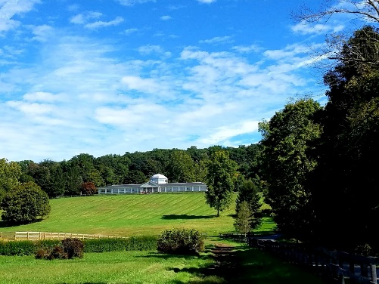
January 14, 2020 (Pawling, NY) – The Global Federation of Animal Sanctuaries (GFAS), the only globally recognized organization providing standards for identifying legitimate animal sanctuaries, awarded Verified status to Akindale Thoroughbred Rescue as of December 1, 2019.
Verification means that Akindale Thoroughbred Rescue meets the criteria of a true equine sanctuary/rescue and is providing humane and responsible care of the animals. To be awarded Verified status, an organization must meet GFAS’s rigorous and peer-reviewed animal care standards which are confirmed by a site visit and they must also adhere to a demanding set of ethical and operational principles. The Verification status also provides a clear and trusted means for the public, donors and grantors to recognize Akindale Thoroughbred Rescue as an exceptional organization.
“We are proud to announce the recent Verification of Akindale Thoroughbred Rescue”, said Daryl Tropea, Ph.D., GFAS Program Director-Equine. “Akindale’s team provides quality care for horses with a broad spectrum of needs. Whether it’s the need to provide a safe haven for senior sanctuary horses, or the need to provide expert rehabilitation care for a horse to move on to a home, they do it all. Education is a significant part of their mission with an emphasis on responsible horse ownership.”
“Although this beautiful farm is clearly designed to meet the needs of rescue and sanctuary horses, it is the dedication and compassion of the Akindale team that stands out the most.”
The GFAS Equine Accreditation Program is made possible by a generous grant from The American Society for the Prevention of Cruelty to Animals® and the Kenneth Scott Charitable Trust.

About Global Federation of Animal Sanctuaries
Global Federation of Animal Sanctuaries (GFAS) is a 501(c) 3 nonprofit organization dedicated to the sole purpose of strengthening and supporting the work of animal sanctuaries, rescues, and rehabilitation centers worldwide. The goal of GFAS in working with and assisting these animal care facilities is to ensure they are supported, honored, recognized and rewarded for meeting important criteria in providing care to the animals in residence. GFAS was founded in 2007 by animal protection leaders from a number of different organizations in response to virtually unchecked and often hidden exploitation of animals for human entertainment and financial profit. The GFAS Board of Directors guides the organization’s work in a collaborative manner. While the board includes those in top leadership at The Humane Society of the United States, International Fund for Animal Welfare, and American Anti-Vivisection Society, all board members serve as individuals dedicated to animal sanctuaries. www.sanctuaryfederation.org.

About Akindale Thoroughbred Horses.
Akindale Thoroughbred Rescue is committed to the rescue, rehab and retraining of Thoroughbreds no longer able to race. ATBR is also dedicated to promoting awareness of the issue of equine slaughter. Akindale Thoroughbred Rescue is a 501(c)(3) private operating foundation.

Akindale is a nationally recognized name, synonymous with the cause. While in the past ATBR has made valuable contributions in saving many thoroughbreds, there are so many more still needing to be rescued.
In order to fulfill its mission of “providing a safe haven for thoroughbreds no longer able to race”, the ATBR has expanded its goals. Realizing that more horses need to be responsibly adopted to private owners, so more can be taken in, they are committed to training and more aggressive communication about the adoption program. For more information, visit www.akindalehorserescue.org.

